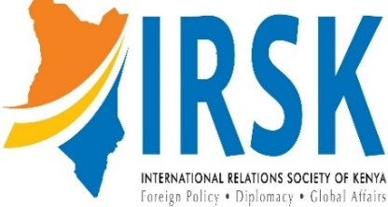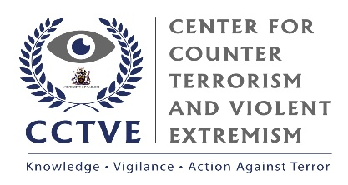

2025 NAIROBI GEOSECURITY FORUM

THEME:
Enhancing Kenya’s Security and Resilience in the Face of Complex Regional Conflicts and Transnational Threats

PROGRAM

Thursday, 24th July 2025

UNIVERSITY OF NAIROBI
Nairobi, Kenya

8:00 AM – 12:30 PM

SESSION ONE
TIME | ACTIVITY
08:00 - 08:30 | ARRIVAL AND REGISTRATION
08:30 - 09:15 | OPENING CEREMONY
Master of Ceremony
Dr. Winnie Rugutt – Lecturer, DDIS, University of Nairobi
Speakers
Welcome Remarks – Prof. Patrick Maluki, Chair, DDIS, University of Nairobi
Introductory Remarks – Mr. Leonard Wanyama, CEO, International Relations Society of Kenya
Opening Remarks – Mr. Jan Ole Voss, Deputy Country Director, Konrad Adenauer Foundation – Kenya
Featured Address – Prof. Jack Odhiambo, Dean, FASS, University of Nairobi
Keynote Address – Hon. John Munyes, President’s Special Envoy for Peace for Ateker Region, Kenya

09:15 - 9:35 | RESEARCH PRESENTATION
Theme: Kenya’s Stability in a Complex Geosecurity Environment
Presenter
Brig. (Rtd.) Willy Wesonga Sidwaka – Independent Security Consultant and Researcher, Kenya

9:35 - 9:50 | DISCUSSANTS
Panelists
Dr. Ochieng Kamudhayi – Senior Lecturer, SHSS, Strathmore University
Dr. Stephen Handa – Senior Lecturer, SLASS, Kenyatta University

9:50 - 10:00 | MENTIMETER POLL
10:00 - 10:20 | OPEN PLENARY SESSION
10:20 - 10:30 | PHOTO SESSION
10:30 - 11:00 | COFFEE/HEALTH BREAK

SESSION TWO
 | EXPERT ROUNDTABLE DISCUSSION
11:00 – 12:00 | Theme: Security Policies, Vulnerabilities and Risk Drivers for Kenya  Moderator  Dr. Kemoli Sagala – Security Expert and Consultant, Kenya  Panelists  Dr. Dan Noel Odaba – Director, Southern Africa, Institute for Economics and Peace  Mr. Stuart Smith – First Secretary, Counter Terrorism, Australian High Commission in Kenya  Dr. Nicodemus Minde – Researcher, Institute for Security Studies – East Africa
12:00 – 12:10 | SUMMMARY AND KEY TAKEAWAYS
Speaker
Dr. Kizito Sabala – Chief Researcher, Center for Counterterrorism and Violent Extremism, University of Nairobi

12:10 – 12:30 | CLOSING CEREMONY
Master of Ceremony
Dr. Winnie Rugutt – Lecturer, DDIS, University of Nairobi

Speakers
Vote of Thanks – Mr. Leonard Wanyama, CEO, International Relations Society of Kenya
Vote of Thanks – Mr. Jan Ole Voss, Deputy Country Director, Konrad Adenauer Foundation – Kenya
Closing Remarks – Prof. Patrick Maluki, Chair, DDIS, University of Nairobi

 | GROUP PHOTO
12:30 Onwards | LUNCH, NETWORKING AND DEPARTURE

